ATX to PCjr Adapter
Owner’s Guide

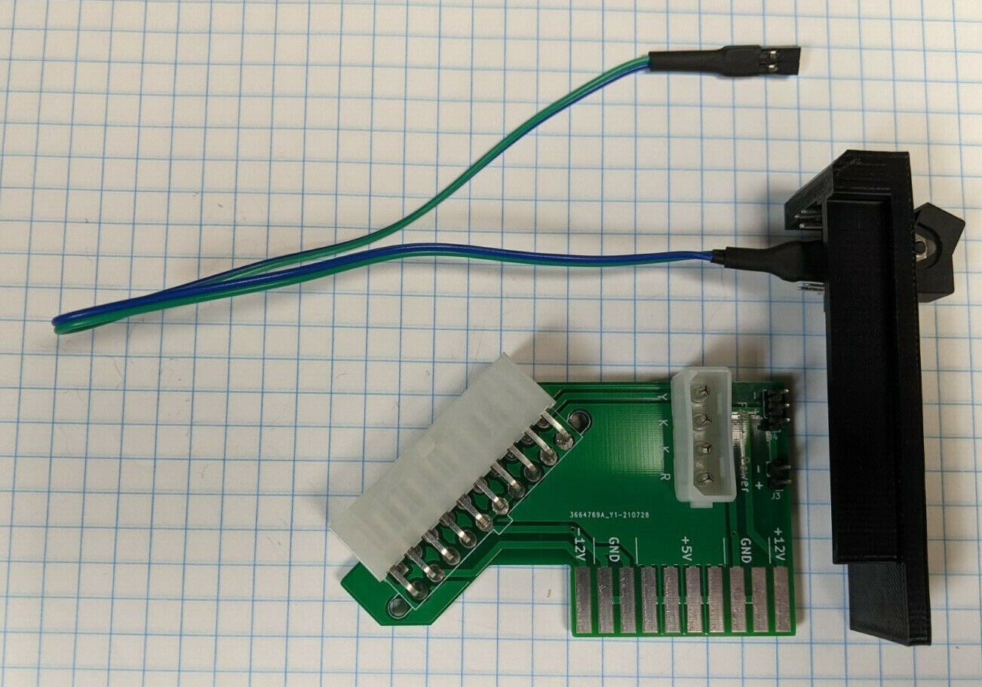

Revised February 2024

Proudly Made in Wisconsin
CONTENTS
INTRODUCTION 3
The PicoPSU 3
Sidecar Power 4
-6V vs -12V 4
Efficiency 4
Compatibility 4
INSTALLATION 5
Checklist 5
Adapter Layout 5
Power Switch Assembly 6
Assembling the Adapter 6
Installing the Adapter 7
WARRANTY 8
INFORMATION
The information found in this document has been compiled with utmost attention to detail. However, this does not guarantee complete accuracy. This document is provided ‘As Is” and may contain technical inaccuracies or typographical errors.

Any references in this document to other companies, products, or services are provided for convenience only and do not in any way serve as an endorsement or recommendation.

Companies, products, or services identified throughout this document may be trademarks or service marks of others.

All rights reserved.

This product originally is derived from the ‘ATX to PCjr’ project created by the user ‘AkBKukU’, otherwise known as Shelby from Tech Tangents. The original GitHub repository can be found here:
https://github.com/AkBKukU/ATX2PCjr

Details on this project, including up-to-date versions of this document, can be found here: https://github.com/leadacid44/ATX2PCjr


Please
Recycle

INTRODUCTION
The ATX to PCjr Adapter will allow you to use a modern ATX-style power supply on an IBM PCjr. Perhaps you are missing the original IBM external power supply, which is frequently separated from the original computer and can be difficult to replace? Or perhaps you want the convenience and efficiency of modern switch mode power supplies? Look no further, the ATX to PCjr Adapter is the product for you!

The PicoPSU
The IBM PCjr originally came with a 33 or 45 watt power supply and was made up of two components: an external 18 volt AC transformer ‘brick’ and an internal AC-to-DC converter board which provided +5, +12, and -12 volt DC power. The ATX standard provides all three of these voltages, making an ATX power supply a convenient solution.

The ATX to PCjr Adapter allows the PCjr to be directly powered by any standard 20-pin ATX power supply, replacing both the external and internal power supply components.

The PicoPSU is what makes the ATX to PCjr a truly remarkable product. As its name implies, the PicoPSU is an extremely small DC to DC power supply capable of converting standard 12 volt DC power into the +3.3, +5, +12, and -12 volt DC power required by the ATX standard. The PicoPSU provides an impressive amount of power relative with its footprint. Its small size allows it to be directly integrated into the ATX to PCjr Adapter, being almost entirely contained within the PCjr. As the PicoPSU has no moving parts, and due to its efficient design, it does not require direct active cooling.

The Mini-Box PicoPSU-80 is the recommended variant of the PicoPSU family, and can be found for purchase on their website here: https://www.mini-box.com/picoPSU-80
Mini-Box also offers a kit containing the PicoPSU-80 and a suitable AC-DC 12 volt, 5 amp switching power adapter: https://www.mini-box.com/picoPSU-80-60W-power-kit

There are many clones of the PicoPSU available on Texelec, eBay, Amazon, AliExpress, etc. which can also work.
Please Note - This document assumes the use of a PicoPSU-80

Sidecar Power
The IBM PCjr was originally designed to have enough power supply capacity for the system itself, as well as one or two sidecar expansion adapters. While the recommended PicoPSU-80 can provide up to 80 watts of power, the PCjr system board itself was not designed to transfer much beyond the original 33 to 45 watts. If your PCjr configuration requires multiple sidecar adapters to be powered, the special IBM “power” sidecar should still be used, as the ATX to PCjr Adapter does not interfere with its operation.

-6V vs -12V
The IBM PCjr Technical Reference manual section System Power Supply specifies +5, +12, and -6 volts DC. Unfortunately the Technical Reference inaccurately documents the power supply board pin out and output voltages. The ATX to PCjr Adapter, as well as the original IBM power supply, outputs -12 volts rather than -6 volts. The only devices which use negative voltages are the 8250A serial port and the LM358 op-amp on the cassette port, and both devices are designed to accept a voltage range of up to -15 volts.

Efficiency
An example IBM PCjr consumes approximately 26 watts at idle and 4 watts when turned off. When converted to use the ATX to PCjr Adapter, the same PCjr consumes only 17 watts at idle and 0.3 watts when turned off.
The original IBM internal power supply board used active linear regulators, which are very inefficient and give off a lot of heat. When converted to use the ATX to PCjr Adapter, there is a significant reduction in the heat generated by the PCjr while in operation.

Compatibility
The ATX to PCjr Adapter is only compatible with the IBM 4860 PCjr.

INSTALLATION
Your ATX to PCjr Adapter package will contain:
- ATX to PCjr Adapter
- Power switch assembly
- This documentation
If you do not have each of these items, contact your dealer before proceeding.

You will need to provide:
- PicoPSU and 12v DC power supply, or other suitable ATX power supply.

Adapter Layout
The following figure shows the ATX to PCjr Adapter layout.
Note the following items:
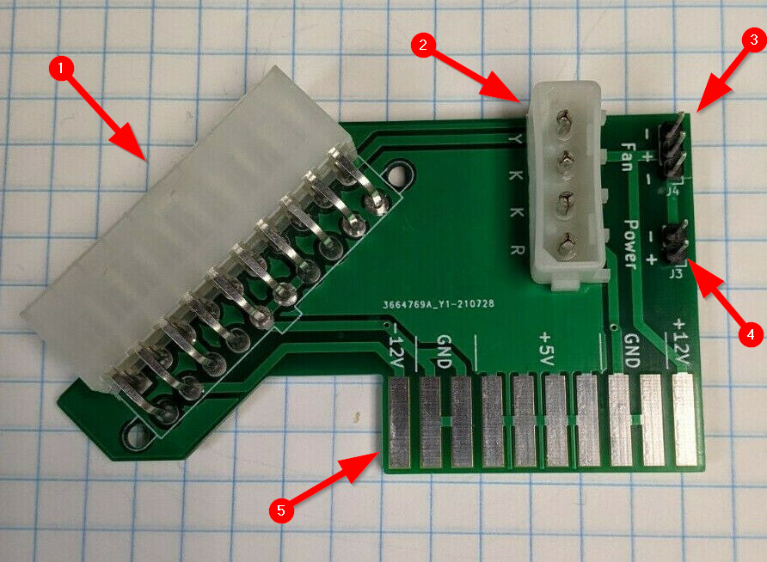Figure 1: ATX to PCjr Adapter
- ATX power connector
- Floppy drive power connector
- 3-pin fan power connector
- 2-pin power switch connector
- PCjr card edge connector.

Power Switch Assembly
Note the following items:
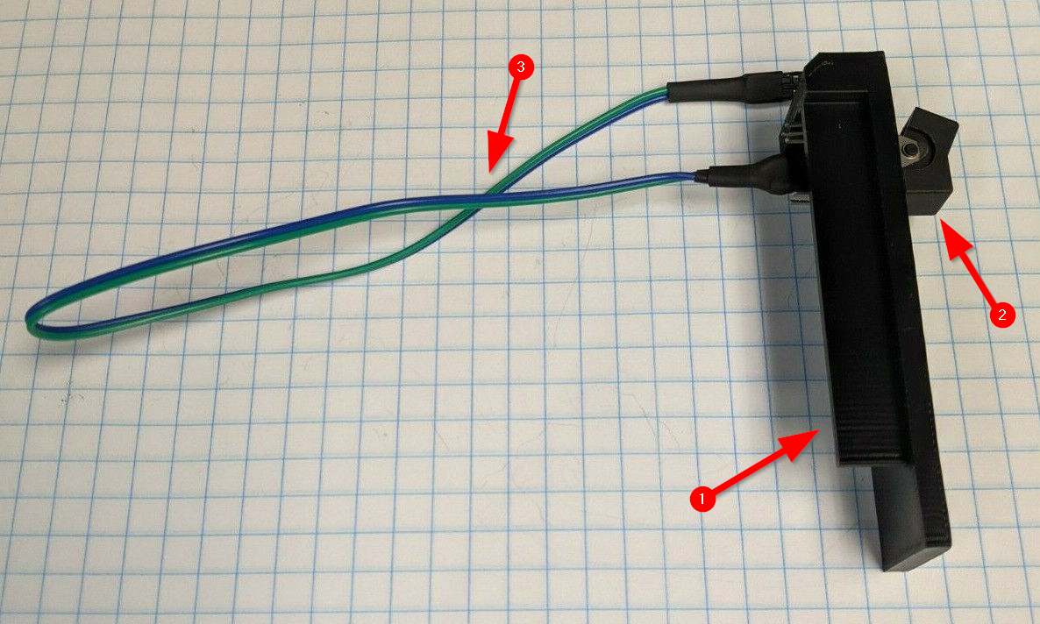Figure 2: Power Switch Assembly
- 3D printed rear bracket
- Power rocker switch
- Power switch cable

Assembling the Adapter

Warning: While the ATX to PCjr adapter is not sensitive to static discharge, the PicoPSU and PCjr both are. Follow static discharge handling rules: don’t perform work in carpeted areas, don’t excessively handle components, limit your moments around the room, ground yourself by touching an earthed metal object before work, etc.

- If connected, disconnect the SATA/PATA power cable from the PicoPSU. It is unnecessary for use with the adapter. Retain the cable in a safe location should you wish to revert to its use.
- Remove the metal retaining nut on the PicoPSU 12V DC In connector.
- Insert the PicoPSU DC connector into the round hole on the 3D printed rear bracket. Tolerances on the bracket may require the connector to be ‘threaded’ or ‘screwed’ into the hole. If necessary for secure attachment, and if there is enough thread remaining on the DC connector, securely reattach the retaining nut.
- Connect the PicoPSU to the ATX to PCjr Adapter by plugging the PicoPSU into the ATX header on the adapter. Note that the keying of the ATX connector only allows the PSU to be attached in one direction. The retaining clip on the PicoPSU must click onto the ATX header. The PicoPSU may be a tight fit onto the ATX header, so use caution when connecting the two.
- Connect the two wire power switch to the two-pin power header labeled ‘Power’ on the adapter. Polarity of the connection does not matter.
- Adapter assembly is complete.

Installing the Adapter
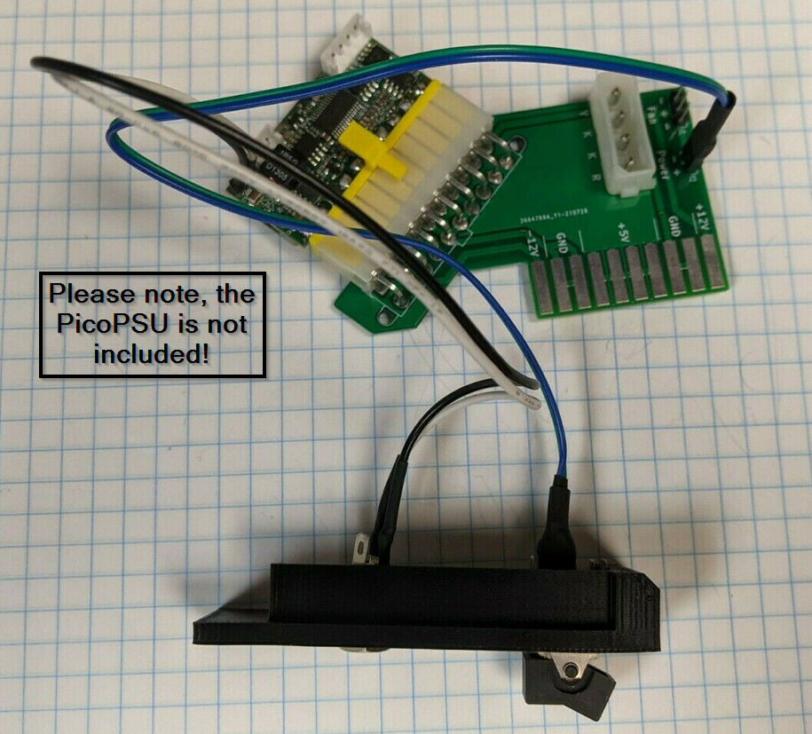Figure 3: Complete Assembly
Caution: Internal components of the PCjr are sensitive to static discharge. Again, follow static discharge handling rules.


Caution: Shock hazards may exist within the PCjr. Do not open the cover unless you have unplugged the system from all electrical sources.

Warning: Be careful when when handling the PCjr power board, components may be hot.

Note: Reference the IBM 4860 PCjr Hardware Maintenance and Service manual sections System Unit Top Cover Removal 100 and Power Board Removal 020 for detailed instructions.

- Turn off power to PCjr and all peripherals (display, printer, etc.)
- Unplug the PCjr’s and peripherals’ power cords from the wall outlets.
- Remove the top cover of the PCjr.
- Unplug the power transformer’s power cable from the rear of the PCjr.
- Disconnect the floppy drive and fan power cables from the power board.
- Gently pull the power board straight up from the system board connector.
- Retain the IBM power board in a safe location should you wish to revert to its use.
- Ensure the power switch of the ATX to PCjr Adapter is set to Off.
- Connect the floppy drive power cable to the adapter. Note that the keying of the connector only allows the cable to be attached in one direction.
- Connect the floppy drive fan power cable to the adapter. Note that the pin configuration of the fan connector allows the cable to be attached in either direction.
- Plug the adapter into the system board by gently pushing it straight down into the system board connector. The components on the adapter will be facing towards the left of the case, just like the original power supply did.
- Fit the switch assembly into the case. The bracket should fit snugly into the ‘V’ shaped notch on bottom of the case and will protrude approximately 2-3mm from the top of the case. Note that the bracket will be slightly ‘wobbly’ until the top cover is replaced.
- Replace the top cover. The bracket will now be firmly in place. The bracket should not prevent top cover from closing. If the bracket causes fitment issues, confirm it is seated correctly into the bottom of the case and is sitting flush with the back of the case. Replacing the top cover will firmly wedge the bracket into place, removing any ‘wobbliness’.
- Plug the 12 volt DC power adapter into the DC In connector on the adapter.
- Plug the PCjr and peripheral power cords into the wall outlets.
- Installation is complete.

WARRANTY
No warranty or guarantee of any kind is expressed or implied. Returns are not accepted. Use of the ATX to PCjr Adapter is entirely at your discretion and risk. Seriously, this is an aftermarket part made for a 40 year old computer by a guy in a shed. Every adapter is tested before it is shipped, but if you’re worried that this may blow up your priceless PCjr, perhaps you should not use it.

